**TASK-06**

Sum the geometric series

**EXPLANATION:**

Write a program that sums the first n items in a geometric series using while loop. User will input the n. use the following formula or use your previous knowledge.

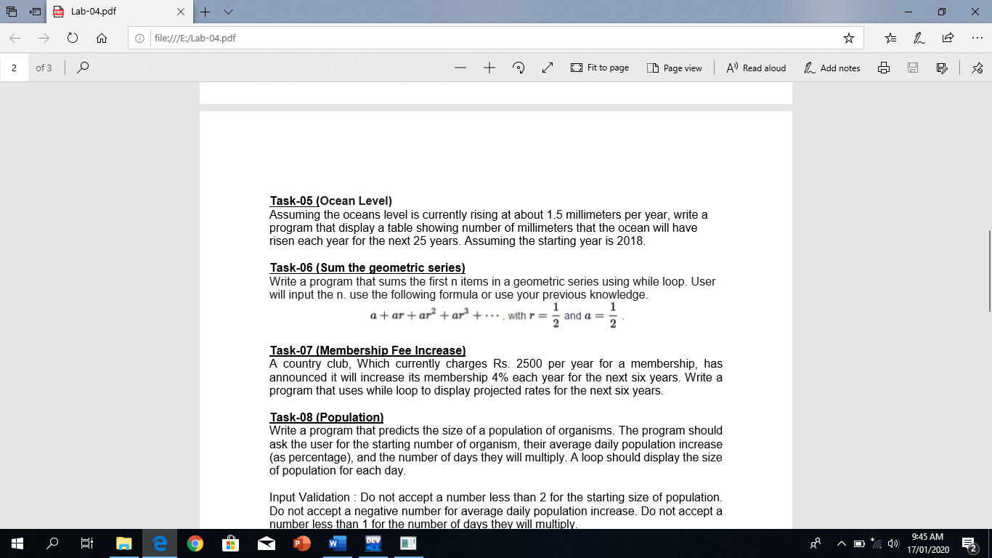

**INPUT:**

#include <iostream>

#include <stdlib.h>

#include <conio.h>

#include <windows.h>

#include <cmath>

using namespace std;

void cin_clear ()

{

cout << "No character or negative value !" ;

Sleep (2000) ;

system("CLS") ;

cin.clear () ;

cin.ignore ( INT_MAX , '\n' ) ;

}

int continuationLoop ()

{

bool check = true , flag = true ;

char option ;

while ( check )

{

system("CLS") ;

cout << "Do you want to continue (y/n) : " ;

option = getch() ;

if ( option == 'y' )

{

system ("CLS") ;

return 1 ;

}

else if ( option == 'n' )

{

return 0 ;

}

}

}

int main ()

{

bool flag = true ;

while (flag)

{

float r = 1.0 / 2 , a = 1.0 / 2 , limit , sum = 0 ;

cout << "Please enter series limit : " ;

while ( ! ( cin >> limit ) || limit < 1 )

{

cin_clear () ;

cout << "Please enter series limit : " ;

}

for ( int i = 0 ; i <= limit ; i++ )

{

sum = a * pow ( r , i ) + sum ;

}

system ("CLS") ;

cout << "Sum of series is " << sum << endl << endl ;

system ("pause") ;

flag = continuationLoop () ;

}

return 0 ;

}

**OUTPUT:**

